**Ideation Phase**

**Brainstorm & Idea Prioritization Template**

|  |  |
| --- | --- |
| Date | 27 June 2025 |
| Team ID | LTVIP2025TMID30720 |
| Project Name | smartsdlc – ai-enhanced software development lifecycle |
| Maximum Marks | 4 Marks |

**A Brainstorm & Idea Prioritization for an AI-Enhanced Software Development Lifecycle**

Brainstorming provides a free and open environment that encourages everyone within a team to participate in the creative thinking process that leads to problem solving. Prioritizing volume over value, out-of-the-box ideas are welcome and built upon, and all participants are encouraged to collaborate, helping each other develop a rich amount of creative solutions.

The software development landscape is on the cusp of a paradigm shift, with Artificial Intelligence (AI) poised to revolutionize every phase of the Software Development Lifecycle (SDLC). For my project, "smartsdlc," the opportunity lies not just in integrating AI, but in creating a cohesive, intelligent platform that addresses persistent pain points and anticipates the future of software creation. This document provides a comprehensive brainstorm of potential features for "smartsdlc" and a structured guide for your team to collaboratively prioritize these ideas.

Referene:

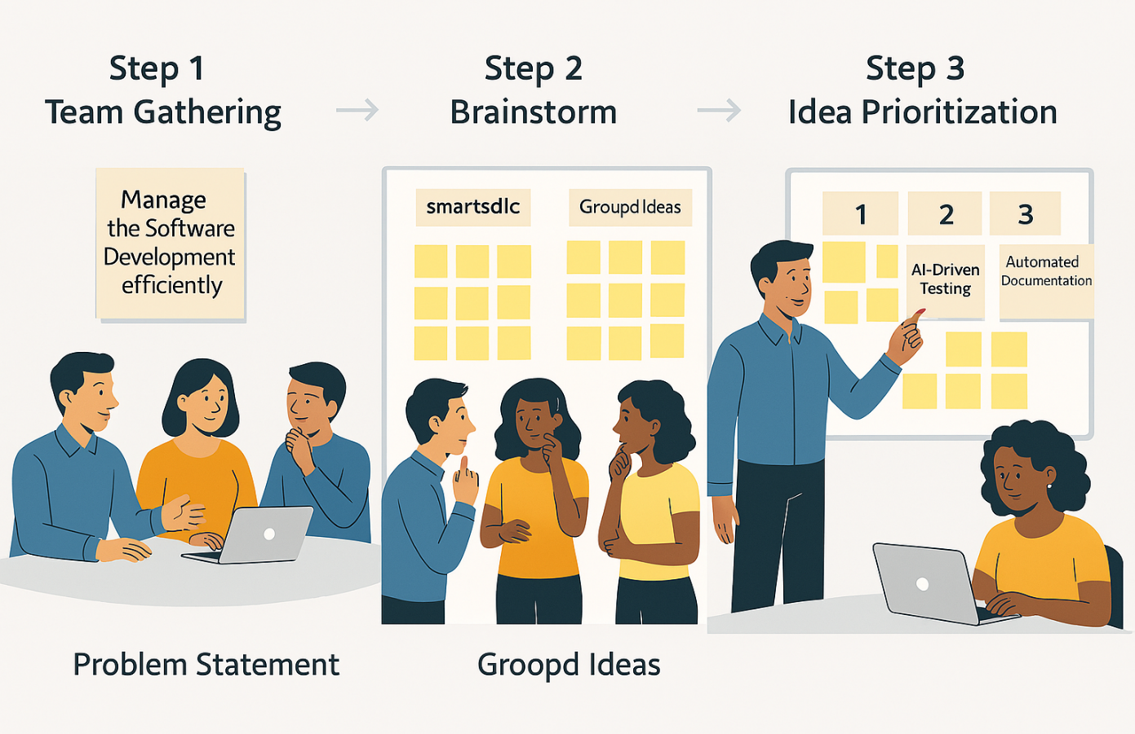

**Efficient Software Development Management**

To foster productivity and innovation in the software development lifecycle, a structured process has been designed:

**Step 1: Team Gathering**

Bringing together diverse skill sets and perspectives is essential. Team members collaboratively discuss goals, share knowledge, and set the stage for innovative thinking.

**Step 2: Brainstorming Session**

Once the team is aligned, a focused brainstorming session encourages the generation of creative solutions. No idea is off-limits—this phase thrives on openness and inclusivity.

**Step 3: Idea Prioritization**

Ideas are grouped and evaluated based on feasibility, impact, and alignment with project goals. High-priority ideas identified in this case include:

* **AI-Driven Enhancements**
* **Robust Testing Strategies**
* **Automated Documentation Solutions**

